**2. METHODOLOGY**

**Study population**

**2.1 Patients with atrial fibrillation:** This study selected 98 patients with atrial fibrillation who were hospitalized in the Affiliated Hospital of Yangzhou University from May 2017 to June 2018.

*Inclusion criteria:* Firstly, there is evidence of paroxysmal, persistent or permanent atrial fibrillation (including ECG, 24-hour Holter monitoring, etc.). Secondly, the patients with non-rheumatic valvular heart disease were confirmed by echocardiography. Thirdly, Born and lived in Yangzhou for a long time, all of them are of Han nationality and have no blood relationship with each other. Fourthly, Those with complete clinical data.

*Exclusion criteria:* Heart color Doppler ultrasound showed the existence of rheumatic heart disease, valvular heart disease, or a history of artificial or biological valve replacement. There were 30 patients with paroxysmal atrial fibrillation and 68 patients with non-paroxysmal atrial fibrillation.

**2.2 Non-AF control:** This study selected 88 non-AF patients hospitalized in the Affiliated Hospital of Yangzhou University from May 2017 to June 2018 as the control group.

*Inclusion criteria:* Firstly, patients who have not been confirmed as having atrial fibrillation by electrocardiogram or 24-hour ambulatory electrocardiogram since birth. Secondly, the patients with non-rheumatic valvular heart disease were confirmed by echocardiography. Thirdly, born and lived in Yangzhou for a long time, all of them are of Han nationality and have no blood relationship with each other. Fourthly, those with complete clinical data.

*Exclusion criteria:* Same atrial fibrillation group

**Genotyping and Single-Nucleotide polymorphism**

The rs2200733 polymorphism locus information was found in the gene bank. According to the relevant literature data and SNP site data, a 413bp fragment containing the rs2200733 polymorphism site was amplified by nested PCR(Table1). DNA was isolated from the blood genomic DNA extraction kit (0.1-1ml) (DP318) of Tiangen Biochemical Technology (Beijing) Co., Ltd. was used to extract DNA from blood samples according to the instructions, and the concentration and purity were detected with a spectrophotometer. The sample was taken out of the -80°C refrigerator and dissolve it at room temperature. Blood sample was taken 200μl of blood sample into a 1.5ml EP tube, add 1L of erythrocyte lysate, invert and mix well, put it in a centrifuge, centrifuge at 10,000 rpm for 1 min, and see if the nuclei are precipitated. The remaining blood samples of the enrolled patients after the five items of coagulation function were routinely checked in the hospital, shaken, mixed, and aliquoted into 1.5ml EP tubes, and stored in a -80°C refrigerator to avoid repeated freezing and thawing of the samples. The digestion reaction of the PCR products was noted that the restriction endonuclease should be placed on ice immediately after being taken out of the -20°C refrigerator, and added in the last step, and the pipette tip must be replaced for each addition.

**Table 1 : The primers used for polymerase chain reaction**

|  |  |  |
| --- | --- | --- |
|  | Primer sequence |  |
| First round primers | Upstream primers | 5′-TGAGATGTAGCAATGTAAACAGCTA-3′ |
|  | Downstream primers | 5′-CCACTGCCCTAAGAGGTCCA-3′ |
| Second round of primers | Upstream primers | 5′-TGTAAACAGCTACTTTTTATATGATC-3′ |
|  | Downstream primers | 5′-GGTAAGGAGCCTAGAGGACAGA -3′ |

.

**2.6 . Statistical analysis**

Statistical analysis was performed using SPSS 23.0 software. The data of clinical categorical variables were expressed as frequency (n), and the χ2 test was used for comparison between groups. Continuous variable data were tested for normal distribution. Normal distribution data were expressed as mean ± standard deviation (x ± s), and independent samples t-test was used for comparison between groups. The bit spacing M (Q1-Q3) represents. The χ2 test was used to verify whether the SNP loci were in Hardy-Weinberg equilibrium. Genotype and allele frequencies were compared between patients and controls using the χ2 test. Logistic regression analysis was used to calculate the odds ratio (OR), 95% confidence interval (95% CI) of genotype, and OR and 95% CI after adjusting for age, sex, history of coronary heart disease, and smoking history. 0.05 means the difference is statistically significant.

1. **RESULTS**

As shown in Table 2, The basic clinical data of 98 patients with atrial fibrillation and 88 control patients were compared. The results showed that there was no statistical difference between the atrial fibrillation group and the control group in terms of gender, BMI, diabetes, and dyslipidemia (P>0.05), but there were differences in age, smoking history, hypertension history, coronary heart disease history, and stroke/TIA history. difference (P<0.05), and the atrial fibrillation group was higher than the control group.

**Table 2: Baseline clinical characteristics of the AF group and the healthy group**.

|  |  |  |  |
| --- | --- | --- | --- |
| Parameters | Atrial fibrillation group (n=98). | Control group (n=88). | P-value |
| Gender (M/F） | 58/40 | 41/47 | 0.086 |
| Age(years) | 73.54±9.04 | 63.24±10.18 | ＜0.001 |
| BMI,kg/m2 | 23.20±3.34 | 23.70±3.38 | 0.316 |
| Paroxysmal atrial fibrillation | 30/68 |  |  |
| History of smoking | 23/75 | 6/82 | 0.002 |
| Hypertension | 73/25 | 44/44 | 0.001 |
| Diabetes mellitus | 25/73 | 19/69 | 0.530 |
| Coronary heart disease | 61/37 | 16/72 | ＜0.001 |
| Stroke/TIA | 45/53 | 11/77 | ＜0.001 |
| Dyslipidemia | 18/80 | 11/77 | 0.271 |

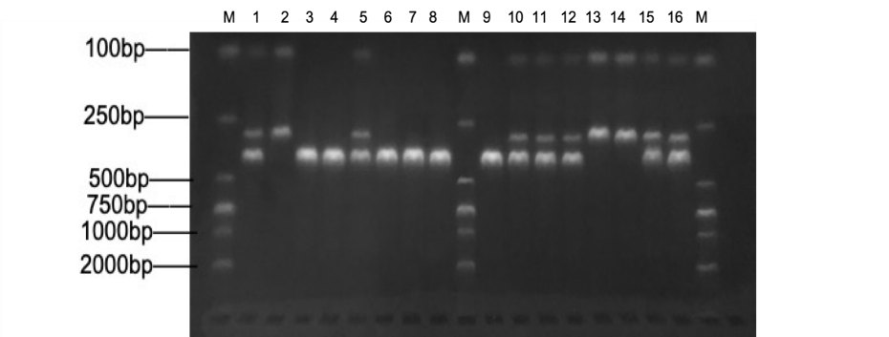

**Figure 1 : Gel electrophoresis of the restriction of poly­merase chain reaction product. Amplified DNA fragments of the PITX2 gene patients with atrial fibrillation digested with restriction enzyme MboI and produced bands are shown in table 3**

M：Marker；1、5、10、11、12、15、16：TCgenotype；2、13、14：CCgenotype；3、4、6、7、8、9：TTgenotype

**Table 3: Fragment lengths after digestion with different genotypes**

|  |  |  |
| --- | --- | --- |
| genotype | number of recognition sites | Fragment length after digestion |
| TT type | 0 | 413bp |
| TC type | 2 | 413bp、293bp、120bp |
| CC type | 1 | 293bp、120bp |

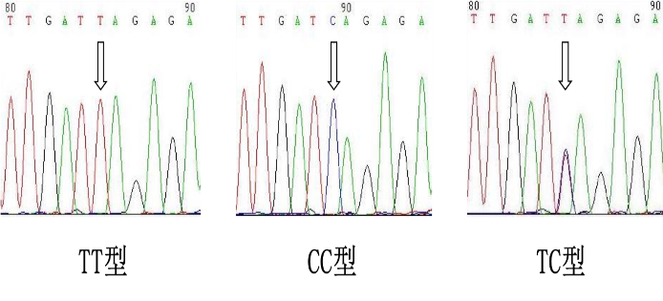

**Figure 2: rs 2200733 site gene sequencing diagram**

The frequencies of different genotypes at the rs2200733 locus in the atrial fibrillation group and the control group are shown in Table 4. Both the atrial fibrillation group and the control group were in line with the Hardy-Weinberg equilibrium, with P values ​​of 0.176 and 0.727, respectively, indicating that the population was genetically balanced. The frequencies of TT, TC, and CC genotypes at rs2200733 (figure2) were 44.9%, 50%, and 5.1% in patients with atrial fibrillation, and 29.55%, 53.41%, and 17.05% in controls, respectively. According to Pearson's chi-square statistical analysis, the genotype of the rs2200733 locus between the atrial fibrillation group and the control group was significantly different (2=9.159, P=0.01). The frequency of TT genotype in atrial fibrillation group was higher than that in control group (2=4.416, P=0.031), and the frequency of CC genotype was lower than that in control group (2=6.892, P=0.009), and the difference was statistically significant. There was no significant difference in TC genotype frequency between the two groups (P=0.642). The frequency of T allele in patients with atrial fibrillation was significantly higher than that in normal controls (2=7.447, P=0.006). The T allele was a risk factor for atrial fibrillation, and the risk of atrial fibrillation in the population carrying the T allele was the same as that in the control group. 1.806 times that of the group (OR=1.806, 95% CI=1.179-2.766, P=0.006).

**Table 4: Genotype frequency and allele frequency distribution of two groups**

|  |  |  |  |  |  |  |  |
| --- | --- | --- | --- | --- | --- | --- | --- |
| group | Number of cases | Genotype frequency n (%) | | | Allele frequency n (%) | | HWE-P |
|  |  | TT | TC | CC | T | C |  |
| Atrial fibrillation group | 98 | 44（44.90） | 49（50.00） | 5（5.10） | 137（69.90） | 59（30.10） | 0.176 |
| Control group | 88 | 26（29.55） | 47（53.41） | 15（17.05） | 99（56.25） | 77（43.75） | 0.727 |
| 2 |  | 4.656 | 0.216 | 6.892 | 7.447 | |  |
| P |  | 0.031 | 0.642 | 0.009 | 0.006 | |  |
| OR |  | 1.943 | 0.872 | 0.262 | 1.806 | |  |
| 95%CI |  | 1.059～3.564 | 0.490～1.552 | 0.091～0.753 | 1.179～2.766 | |  |

According to logistic regression analysis (Table 5) with the CC genotype as the reference, the population with the TC genotype (OR=3.128, 95% CI=1.053-9.287, P=0.04) or the TT genotype (OR=5.077, 95) %CI=1.653～15.595, P=0.005) increased the risk of atrial fibrillation, and the risk of TT genotype was greater. After adjusting for age, gender, history of coronary heart disease, hypertension, and smoking history, people with TT genotype still had an increased risk of atrial fibrillation (AOR*=4.557, 95% CI=1.129-18.396, P*= 0.033), but the incidence of atrial fibrillation in people with TC genotype was not significantly different from CC genotype (P=0.259). By establishing a genetic model, compared with genotype TT, genotype TC and CC can reduce the risk of atrial fibrillation (OR=0.515, 95% CI=0.281-0.944, P=0.032). There was still statistical significance after the factors of heart disease and smoking history (AOR*=0.425, 95% CI=0.201-0.900, P*=0.025).

**Table 5 : SNP rs 2200733 logistic regression analysis of gene polymorphisms and susceptibility to atrial**

|  |  |  |  |  |  |  |  |
| --- | --- | --- | --- | --- | --- | --- | --- |
| rs2200733 | allele | Atrial fibrillation group | Control group | ORvalue（95%CI） | Pvalue | AOR*value（95%CI） | P*value |
| genotype | CC | 5 | 15 | 1 |  |  |  |
|  | TC | 49 | 47 | 3.128（1.053～9.287） | 0.040 | 2.207（0.558~8.723） | 0.259 |
|  | TT | 44 | 26 | 5.077（1.653～15.595） | 0.005 | 4.557（1.129~18.396） | 0.033 |
| Stealth model | TT | 44 | 26 | 1 |  |  |  |
|  | TC+CC | 54 | 62 | 0.515（0.281~0.944） | 0.032 | 0.425（0.201~0.900） | 0.025 |
| Dominant model | CC | 5 | 15 | 1 |  |  |  |
|  | TT+TC | 93 | 73 | 3.822（1.327~11.004） | 0.013 | 3.072（0.819~11.527） | 0.096 |
| Additive model | TC | 49 | 47 | 1 |  |  |  |
|  | TT+CC | 49 | 41 | 1.146（0.644~2.040） | 0.642 | 1.546（0.749~3.194） | 0.239 |
| Note: The AOR* value and P* value were adjusted for age, sex, history of hypertension, history of coronary heart disease, and history of smoking, respectively, after adjusting the OR value and P value . | | | | | | | |